**ANALYSIS OF COVID-19 IN INDIA**

* Map of India
* Population of Various States & Union Territories of India
* Confirmed Cases in India
* Active Cases in India
* Recovered Cases in India
* Deceased Cases in India
* Five states/UT which have highest active cases
* Five states/UT which have highest confirmed cases
* Five states/UT which have highest recovered cases
* Five states/UT which have highest deceased cases
* Five states/UT which have lowest active cases
* Five states/UT which have lowest confirmed cases
* Five states/UT which have lowest recovered cases
* Five states/UT which have lowest deceased cases
* Dashboard-1 : Confirmed Cases, Active Cases, Recovered Cases and Deceased Cases in India
* Dashboard-2 : Top Five Confirmed Cases, Active Cases, Recovered Cases and Deceased Cases in India
* Dashboard-3 : Top Five Lowest Confirmed Cases, Active Cases, Recovered Cases and Deceased Cases in India

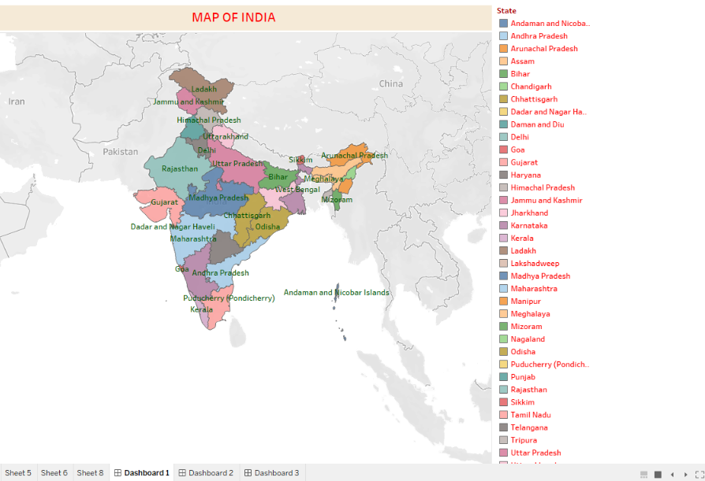

**POPULATION OF THE STATES AND UNION TERRITORIES**

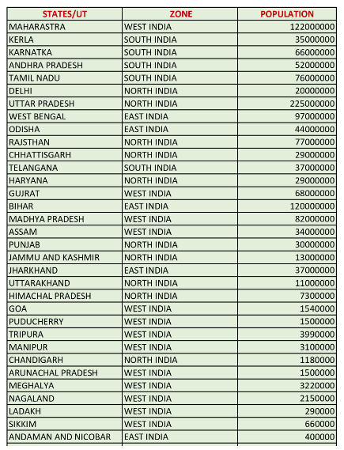

**Data of Confirmed Cases, Active Cases, Recovered Caese and Deceased Cases**

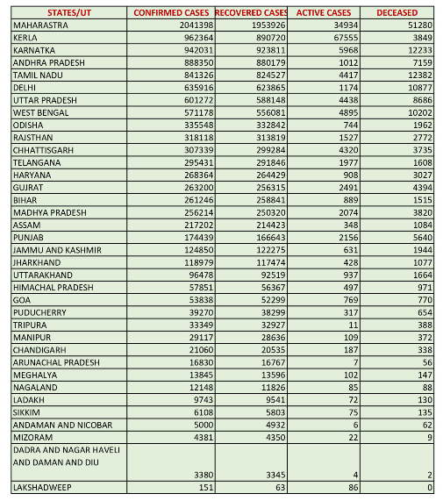

**TEST AND RECOVERY CASES OF CORONA**

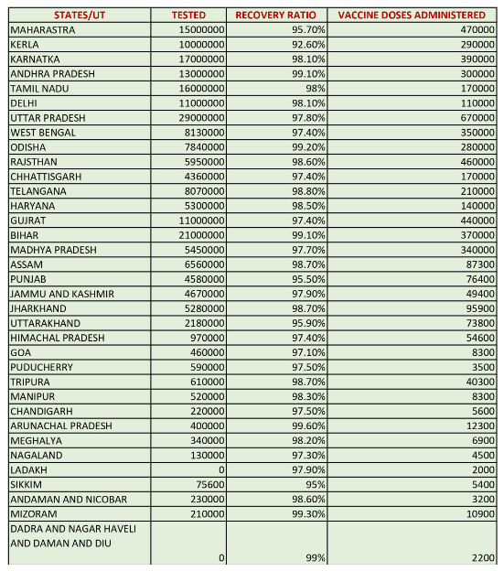

**Note : Here all the data are collected till 7th February 2021**

